Project Title
FedEx Supply Chain Logistics Analysis and Performance Dashboard using Microsoft Power BI
Dataset Name and Description
Dataset Name: FedEx Supply Chain Logistics Dataset
Description:
The FedEx Supply Chain Logistics Dataset contains comprehensive information related to global shipment operations and supply chain activities. It includes 10,324 shipment records across 43 countries, covering various aspects such as shipment schedules, transportation modes, freight costs, delivery performance, vendor information, manufacturing sites, product details, shipment weight, insurance costs, and delivery status.
The dataset provides valuable insights into logistics operations by enabling the analysis of shipment trends, transportation efficiency, delivery timeliness, operational costs, vendor performance, and product distribution. Its multidimensional nature makes it an ideal dataset for Exploratory Data Analysis (EDA) and interactive business intelligence reporting using Microsoft Power BI.

Dashboard Objective
The primary objective of this dashboard is to transform raw logistics data into meaningful business insights through interactive visualizations and key performance indicators. The dashboard is designed to monitor shipment performance, analyze freight costs, evaluate delivery efficiency, examine vendor and product performance, and identify operational trends across different countries.
Specifically, the dashboard aims to:
- Monitor overall logistics performance using key performance indicators (KPIs).
- Analyze shipment trends and geographical distribution of deliveries.
- Evaluate freight costs, shipment modes, and delivery efficiency.
- Assess vendor and manufacturing site performance.
- Identify high-performing products, brands, and molecule types.
- Enable interactive analysis through slicers, drill-through, and custom tooltips.
- Support data-driven decision-making by providing clear, actionable insights into supply chain operations.

Screenshots of Dashboard
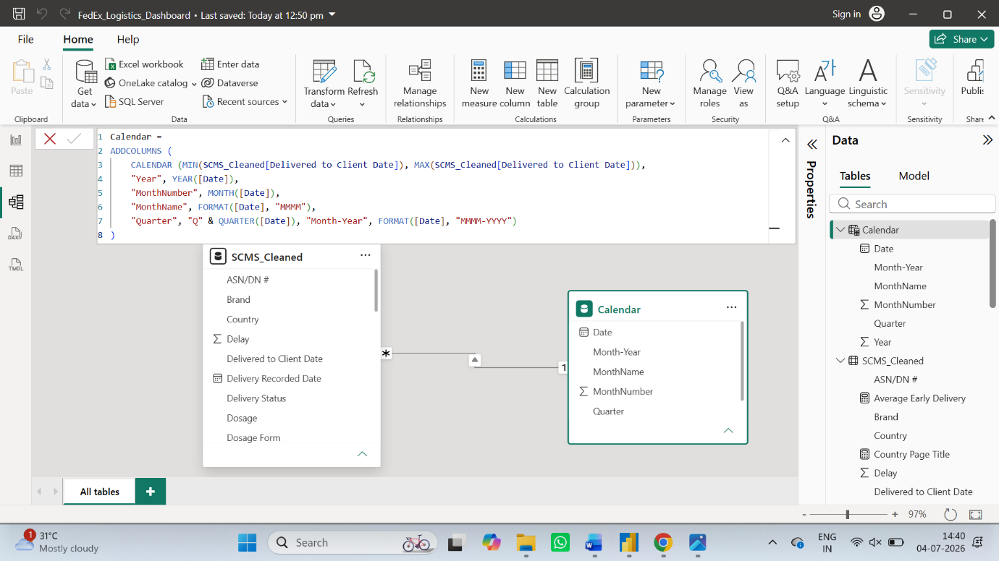
Figure 1: Calendar Table (DAX)
Calendar table created using DAX to support time-based analysis, including Year, Month, Quarter, and Month-Year hierarchy for trend reporting.

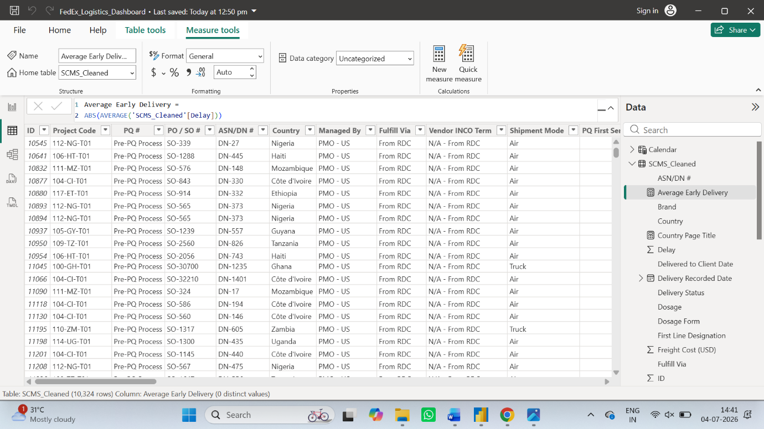
Figure 2: Average Early Delivery Measure
DAX measure developed to calculate the average number of days shipments were delivered ahead of schedule, supporting logistics efficiency analysis.

Figure 3: Dynamic Country Page Title Measure
Dynamic DAX measure used to automatically update the drill-through page title based on the selected country, improving report readability and user experience.
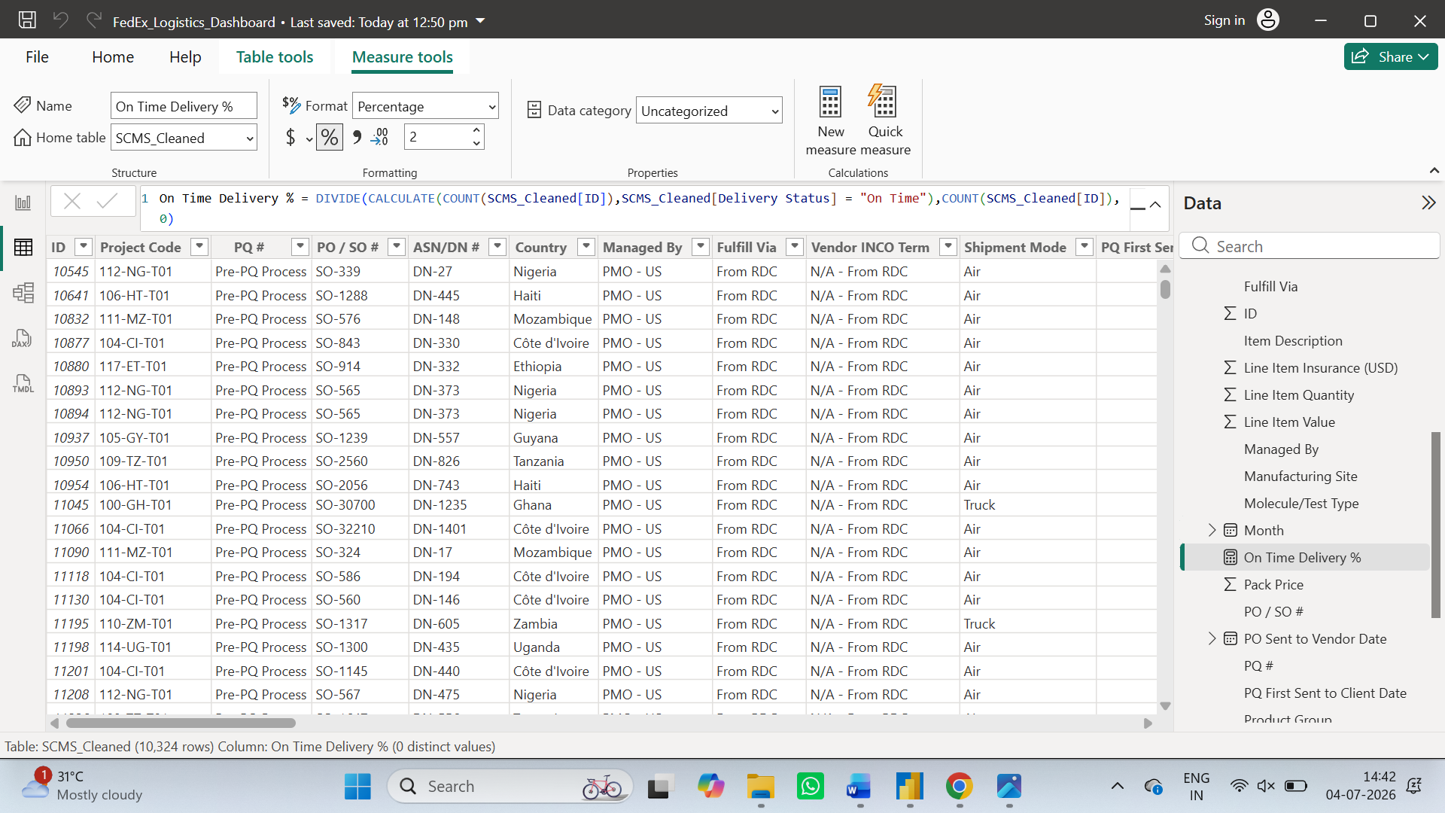
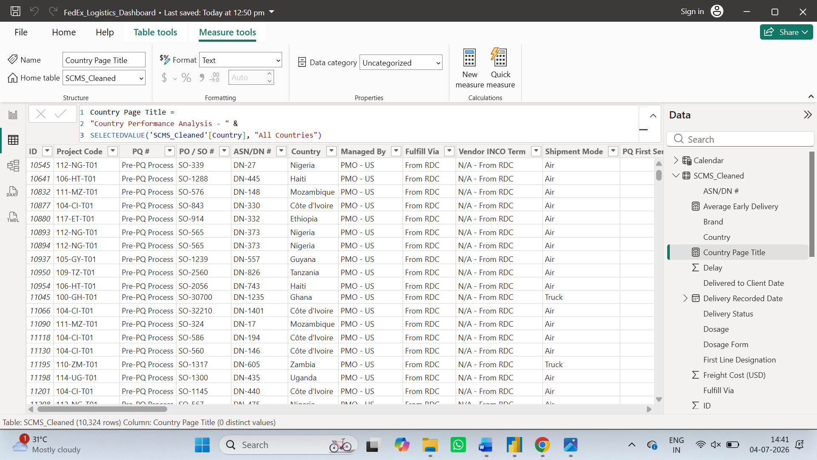
Figure 4: On-Time Delivery % DAX Measure
DAX measure created to calculate the percentage of shipments delivered on time, enabling KPI tracking and performance evaluation across the dashboard.

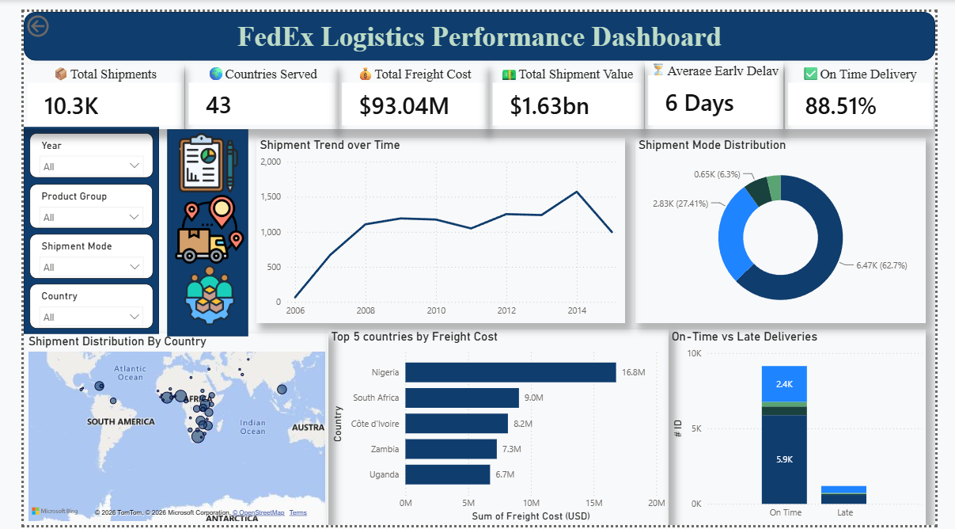
Figure 5: Executive Overview Dashboard
Executive Overview dashboard presenting key logistics KPIs, shipment trends, shipment mode distribution, global shipment distribution, top countries by freight cost, and delivery performance for overall business monitoring.
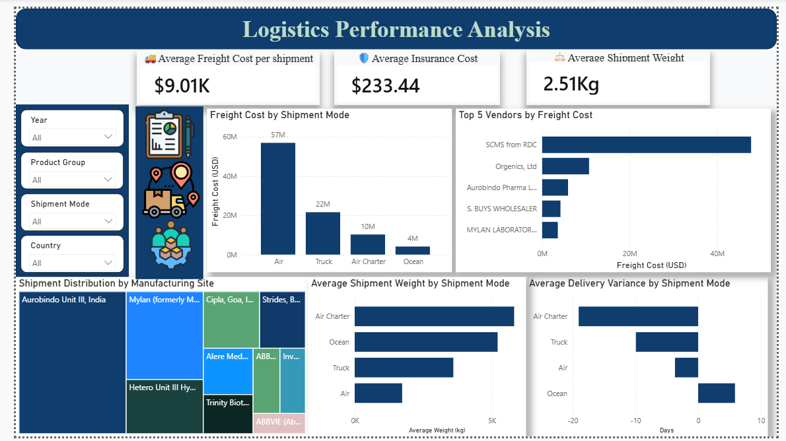
Figure 6: Logistics Performance Analysis Dashboard
Logistics Performance dashboard providing detailed insights into freight cost, insurance cost, shipment weight, manufacturing sites, vendor-wise freight expenditure, shipment weight by transport mode, and delivery variance analysis.

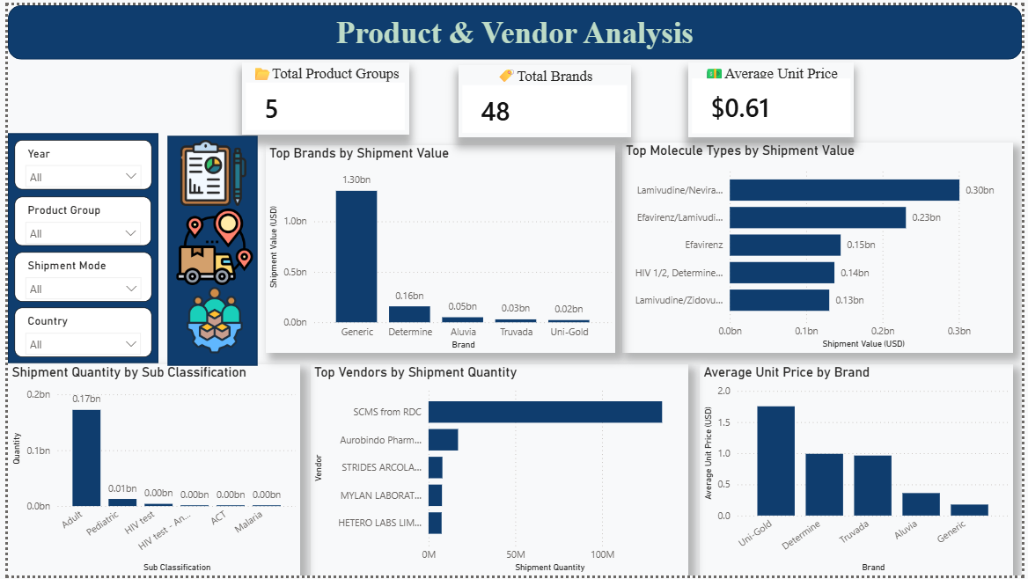
Figure 7: Product & Vendor Analysis Dashboard
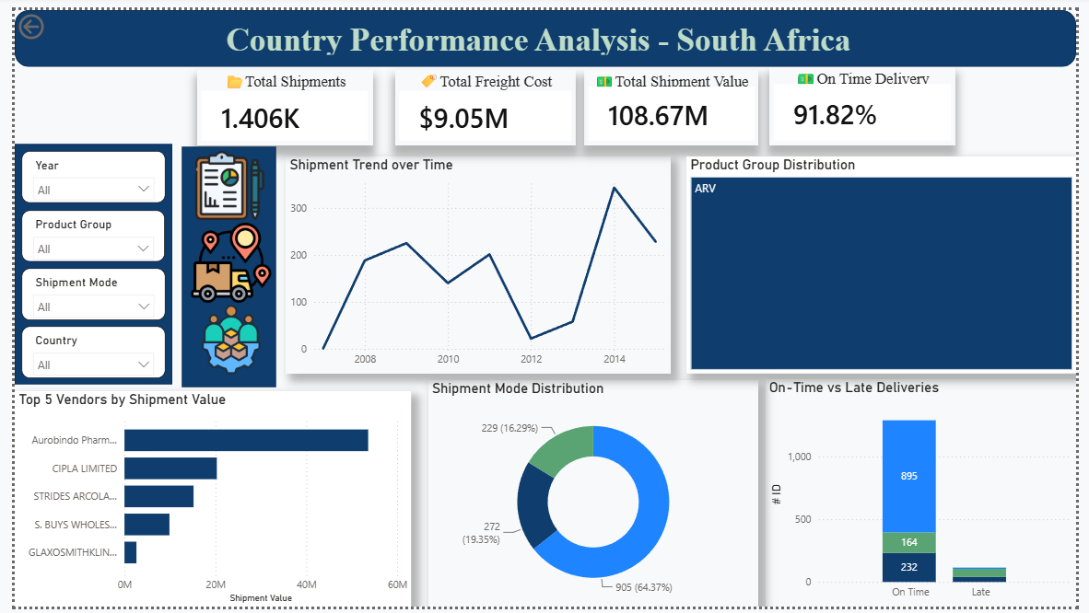
Product & Vendor Analysis dashboard highlighting product groups, brands, molecule types, vendor shipment quantity, shipment quantity by product classification, and average unit price across brands.

Figure 8: Country Performance Analysis
Drill-through dashboard displaying country-specific logistics performance, including shipment value, freight cost, shipment trends, product group distribution, vendor analysis, shipment mode distribution, and delivery performance.

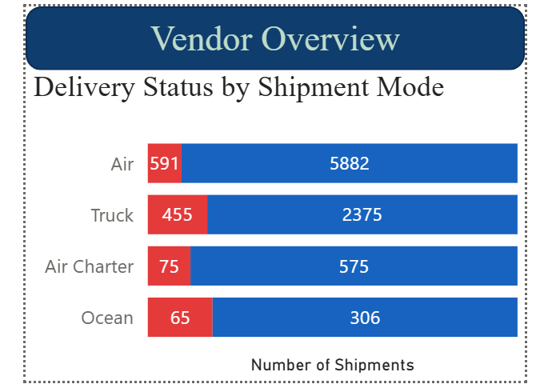

Figure 9: Vendor Overview Tooltip Page
Dedicated tooltip page created to enhance user interaction by presenting delivery status across different shipment modes without leaving the current report page.
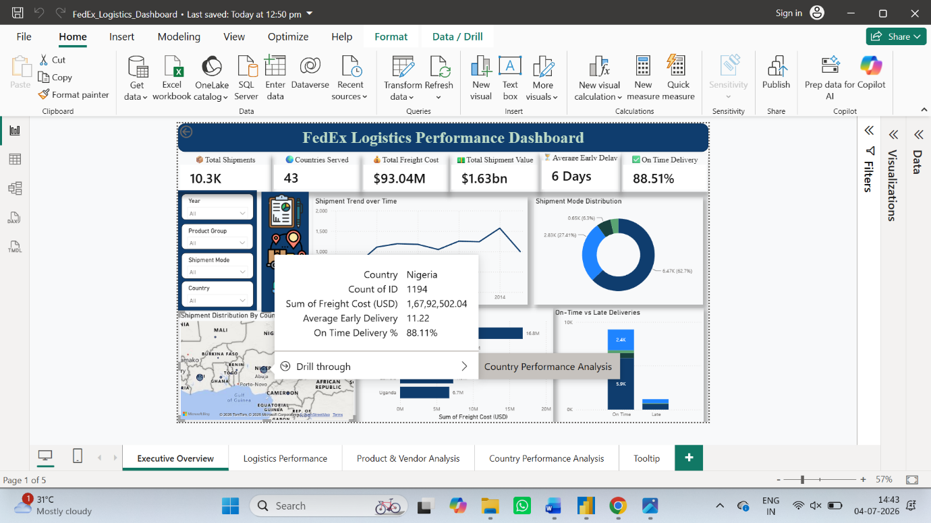
Figure 10: Drill-through Navigation
Drill-through functionality allowing users to navigate from the Executive Overview map to a detailed country-level performance dashboard for deeper analysis.

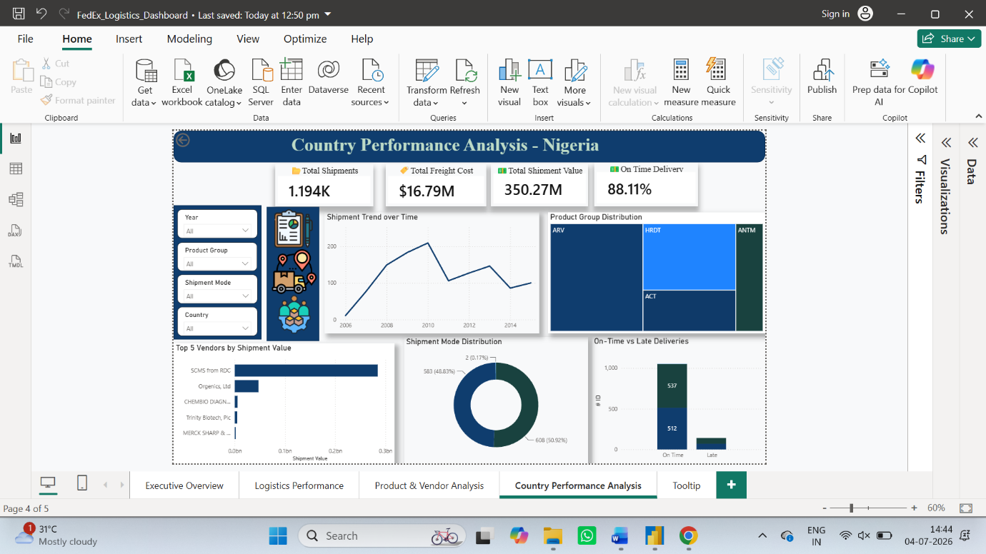
Figure 11: Country Performance Dashboard after Drill-through
Dynamic country-specific dashboard generated through drill-through, displaying detailed logistics insights based on the selected country.
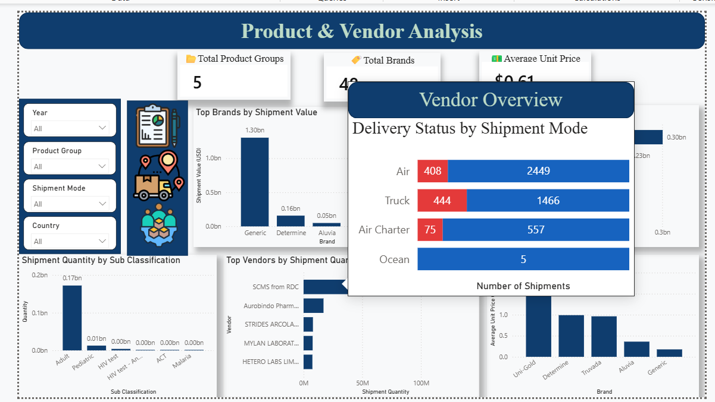
Figure 12: Custom Report Tooltip
Custom report page tooltip displaying shipment mode-wise delivery status, providing additional insights when hovering over vendor-related visuals.

Key Insights and Explanations
The Power BI dashboard provides comprehensive insights into the performance of FedEx's global logistics operations by analyzing shipment trends, transportation costs, delivery efficiency, and product distribution.
1. Executive Overview
- The dashboard presents an overall view of logistics operations through key performance indicators, including total shipments, countries served, freight cost, shipment value, average delivery performance, and on-time delivery percentage.
- Shipment trends over time help identify changes in shipment volume and operational demand.
- The geographical distribution map highlights the countries with the highest shipment activity.
- The delivery status analysis indicates that the majority of shipments were delivered on time, demonstrating efficient logistics management.
2. Logistics Performance Analysis
- Freight cost analysis reveals how transportation expenses vary across different shipment modes.
- Shipment mode comparison highlights differences in delivery performance and average shipment weight.
- Vendor analysis identifies suppliers contributing the highest logistics costs.
- Manufacturing site analysis shows the distribution of shipment volumes across production locations.
- Delivery performance metrics help identify transportation methods that consistently achieve timely deliveries.
3. Product & Vendor Analysis
- Brand-wise analysis identifies products contributing the highest shipment value.
- Molecule/Test Type analysis highlights the pharmaceutical products with the greatest business contribution.
- Sub-classification analysis provides insights into shipment quantity across different product categories.
- Vendor analysis identifies suppliers responsible for the highest shipment quantities.
- Average unit price analysis highlights pricing variations among different product brands.

4. Interactive Features
- Drill-through functionality enables detailed country-level analysis from the executive dashboard.
- Custom tooltips provide additional contextual information without overcrowding the visuals.
- Interactive slicers allow users to filter data dynamically by Year, Country, Product Group, and Shipment Mode.

Business Impact Summary
The developed dashboard transforms complex logistics data into an intuitive and interactive business intelligence solution that supports informed decision-making across supply chain operations.
The analysis helps stakeholders:
- Monitor overall logistics performance using real-time key performance indicators.
- Identify countries, shipment modes, and vendors contributing significantly to freight costs.
- Evaluate delivery performance and monitor on-time shipment rates.
- Optimize transportation strategies by comparing shipment modes and operational costs.
- Understand product and brand performance through shipment value and quantity analysis.
- Detect operational trends and potential inefficiencies within the supply chain.
- Improve strategic planning by enabling interactive exploration through filters, drill-through analysis, and custom tooltips.
- Support data-driven decisions that can improve operational efficiency, reduce logistics costs, and enhance overall supply chain performance.
Overall, the dashboard serves as a comprehensive decision-support tool that converts raw shipment data into meaningful business insights, enabling logistics managers to monitor performance, identify improvement opportunities, and optimize supply chain operations efficiently.

